Najee Pitt-Clarke

Bermuda International | Winger/Centre / Fullback / Halfback
Email: npclarke98@gmail.com | Phone: 07907 820269 | Reading, UK
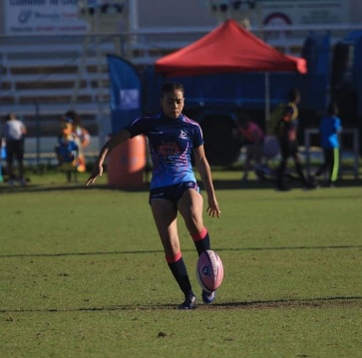
Instagram: @Nxj_____

Education University of Reading – BSc Food Business and Marketing

Positions
7s Rugby: Fly-Half (10), Scrum-Half (9), Wing
15s Rugby: Winger (11/14), Fullback (15)

Career Highlights & Experience

Leadership & Early Success
- Captain, The Berkeley Institute Women’s Rugby Team (2016).
- Joined Teachers RFC touch rugby squad at 16, transitioning to full contact.

International Experience
- Represented Bermuda: Calgary Stampede 7s (2016), Ariel Re Bermuda 7s (2016–2019), RAN 7s Barbados(2018).
- Selected for Bermuda Trinidad & Tobago RAN 7s (2025).
- Represented West Indies: Tropical 7s (2024) – Placed 2nd overall.

University / Town & County Rugby
- University of Reading Women’s Rugby Team & Reading Kites RFC.
- Debut: Try in 44–0 win vs Royal Holloway (Nov 2024).
- Berkshire County (Gill Burns Championship 2025): 2 tries; 2 team wins (first since 2023).
- Progressed to Reading Abbey RFC (2025), a higher division club.
- Recruited for Berkshire County (2026).

Tournament Success
- Find Rugby Now (FRN): 2nd in Elite Women’s 7s Tournament.
Outstanding Performances
– University of Reading Hat-trick vs Sussex 1’s (56–19).
- 8 tries in 118–0 victory vs Sussex 2.
- Progressed to Elite 7’s team FRN Find Rugby Now 2026
- Professional Experience Life University Recruitment Camp (Atlanta, GA, 2017) – Partial scholarship awarded.

Key Strengths
- Explosive pace and agility, dangerous in open play.
- Versatile across multiple backline positions.
- Strong leadership and tactical awareness.
- Consistent performance and composure under pressure.

